NAME: Alli Daity Rakshitha
REG NO:192311181
COURSE CODE:1708
ARTIFICIAL INTELLIGENCE

1.Write the python program to solve 8-Puzzle problem
Python code:
from collections import deque

s=input("Enter puzzle: ") q=deque([(s,[])]) v={s}

while q:
x,p=q.popleft() if x=="123456780": print("Solution:") for a in p+[x]:
print(a[:3]);print(a[3:6]);print(a[6:]);print() break i=x.index("0") for j in [i-3,i+3,i-1,i+1]: if 0<=j<9 and abs(i%3-j%3)<=1:
a=list(x);a[i],a[j]=a[j],a[i];a=''.join(a) if a not in v:v.add(a);q.append((a,p+[x])) else: print("No solution")

Output:
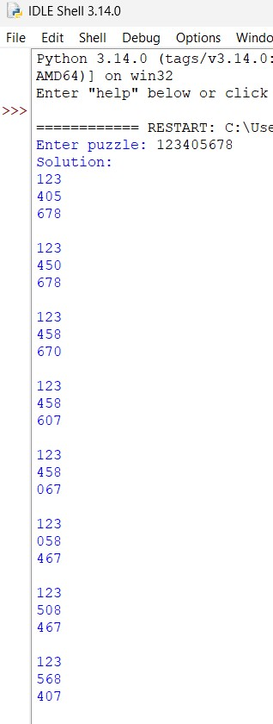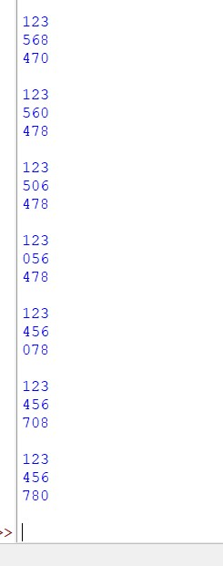

2.Write the python program to solve 8-Queen problem
Python code:
def solve(r, q): if r == 8: for i in range(8):
print(" ".join("Q" if q[i] == j else "." for j in range(8))) return True for c in range(8):
if c not in q and all(abs(c-x) != r-i for i,x in enumerate(q)):
if solve(r+1, q+[c]):
return True return False

solve(0, []) Output:
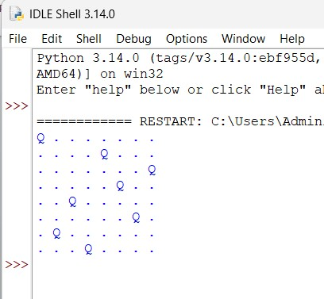

3.Write the python program for Water Jug Problem
Python code:
a = 0 b = 0 print(a, b)

while a != 2: if a == 0: a = 4 elif b == 3: b = 0 else: x = min(a, 3-b) a = a-x b = b+x print(a, b)
Output:
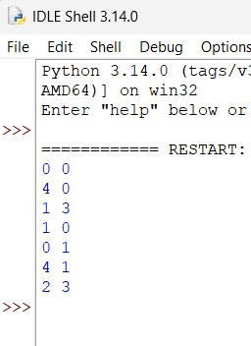
4.Write the python program for Missionaries Cannibal problem
Python code:
from collections import deque

q = deque([((3,3,1), [])]) v = {(3,3,1)} moves = [(1,0),(2,0),(0,1),(0,2),(1,1)]

while q:
(m,c,b), p = q.popleft() if (m,c,b) == (0,0,0): for x in p + [(m,c,b)]:
print(x) break for dm,dc in moves:
nm = m-dm if b else m+dm nc = c-dc if b else c+dc
nb = 1-b if 0<=nm<=3 and 0<=nc<=3: if (nm==0 or nm>=nc) and (3-nm==0 or 3-nm>=3-nc):
s=(nm,nc,nb) if s not in v:
v.add(s); q.append((s,p+[(m,c,b)]))
Output:
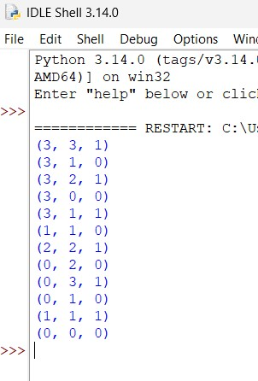

5.Write the python to implement Travelling Salesman Problem
Python code:
from itertools import permutations

d=[[0,10,15,20],[10,0,35,25],[15,35,0,30],[20,25,30,0]] best=999 path=None

for p in permutations(range(1,4)):
r=(0,)+p+(0,) cost=sum(d[r[i]][r[i+1]] for i in range(4)) if cost<best: best=cost path=r

print("Path:",path) print("Minimum cost:",best) Output:
